1. Welcome to the Preview

Welcome to your sneak peek of the Deep Learning Nanodegree Foundation program!

We know you may be curious about the content and experience of the program, so we created this mini experience as a way for you to get a taste for what to expect in the degree as a whole. Here you'll be able to preview content from the first week of class.

After you look through all the material, we hope you are excited to join us in the actual classroom. When you're ready, visit www.udacity.com/deep-learning to enroll today.

We'll see you in class!

The Deep Learning Nanodegree Foundation Team

1. Welcome to the Deep Learning Nanodegree Foundations Program

Mat Leonard and Luis Serrano

1. Meet Your Instructors

Primary instructors, Sample, SQL for Python. Google machine learning recommendations for viewers on YouTube.

1. Program Structure

# Program Structure

The Deep Learning Nanodegree Foundation program is divided into five parts, giving you a thorough understanding of deep learning, and covering some of the major topics.

## Introduction

The first part is an introduction to the program as well as a couple lessons covering tools you'll be using. You'll also get a chance to apply some deep learning models to do cool things like transferring the style of artwork to another image.

We’ll start off with a simple introduction to linear regression and machine learning. This will give you the vocabulary you need to understand recent advancements, and make clear where deep learning fits into the broader picture of Machine Learning techniques.

## Neural Networks

In this part, you'll learn how to build a simple neural network from scratch using python. We'll cover the algorithms used to train networks such as gradient descent and backpropagation.

The **first project** is also available this week. In this project, you'll predict bike ridership using a simple neural network.

**[[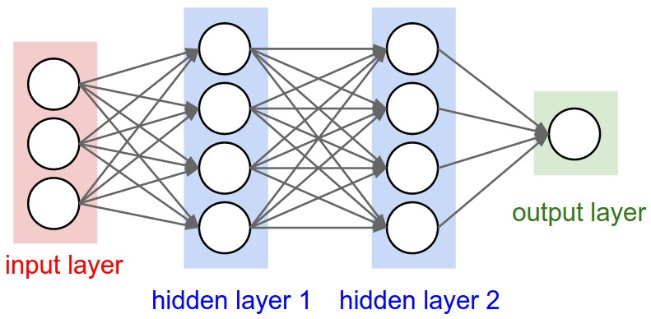](https://classroom.udacity.com/courses/nd101-preview/lessons/426d0195-bdf8-4099-af00-fa1e236c244e/concepts/36217037-98a7-441e-874a-251a0d13b2b4)](https://classroom.udacity.com/courses/nd101-preview/lessons/426d0195-bdf8-4099-af00-fa1e236c244e/concepts/36217037-98a7-441e-874a-251a0d13b2b4)**

You'll also learn about model evaluation and validation, an important technique for training and assessing neural networks. We also have guest instructor Andrew Trask, author of [**Grokking Deep Learning**](https://www.manning.com/books/grokking-deep-learning), developing a neural network for processing text and predicting sentiment.

## Convolutional Networks

Convolutional networks have achieved state of the art results in computer vision. These types of networks can detect and identify objects in images. You'll learn how to build convolutional networks in TensorFlow.

You'll also get the **second project,** where you'll build a convolutional network to classify dog breeds in pictures.

**[[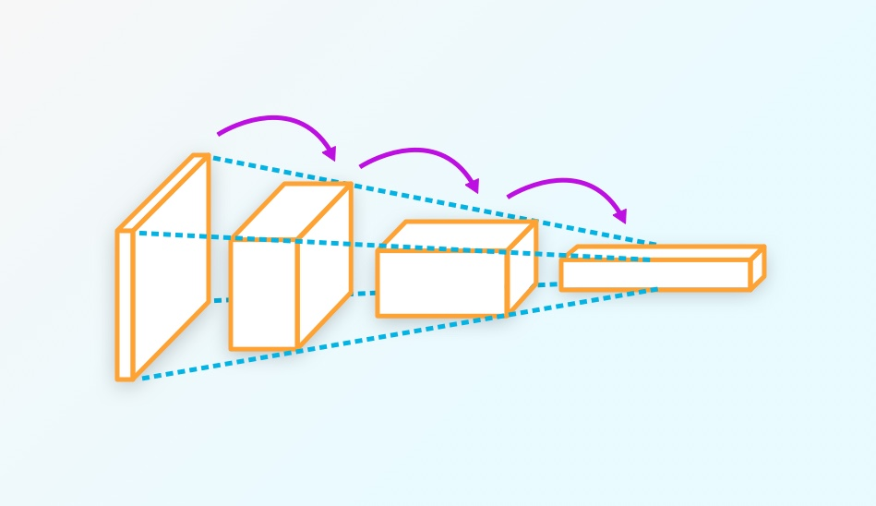](https://classroom.udacity.com/courses/nd101-preview/lessons/426d0195-bdf8-4099-af00-fa1e236c244e/concepts/36217037-98a7-441e-874a-251a0d13b2b4)](https://classroom.udacity.com/courses/nd101-preview/lessons/426d0195-bdf8-4099-af00-fa1e236c244e/concepts/36217037-98a7-441e-874a-251a0d13b2b4)**

You'll also use convolutional networks to build an autoencoder, a network architecture used for image compression and denoising. Then, you'll use a pretrained neural network (**[VGGnet](https://arxiv.org/pdf/1409.1556.pdf" \t "_blank)**), to classify images of flowers the network has never seen before, a technique known as transfer learning.

## Recurrent Neural Networks

In this part, you’ll learn about Recurrent Neural Networks (RNNs) — a type of network architecture particularly well suited to data that forms sequences like text, music, and time series data. You'll build a recurrent neural network that can generate new text character by character.

**[[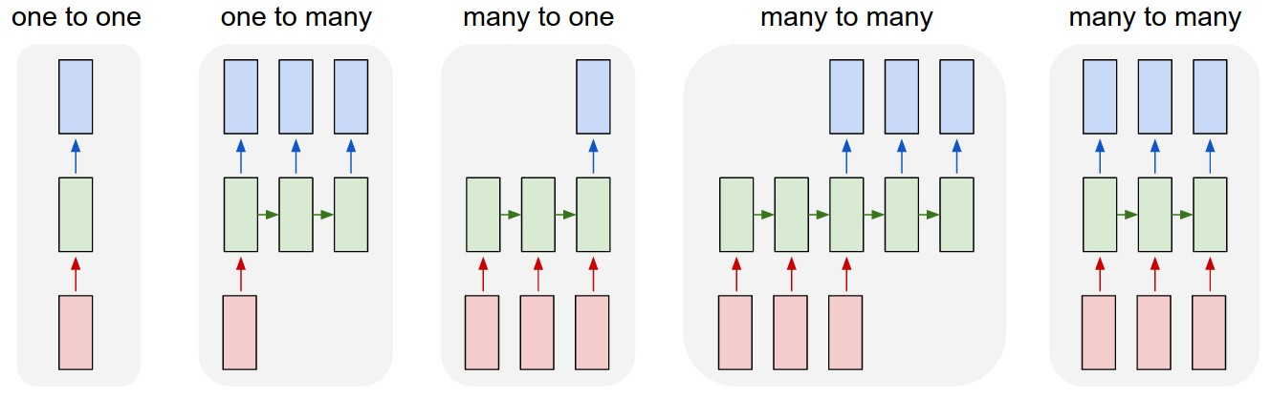](https://classroom.udacity.com/courses/nd101-preview/lessons/426d0195-bdf8-4099-af00-fa1e236c244e/concepts/36217037-98a7-441e-874a-251a0d13b2b4)](https://classroom.udacity.com/courses/nd101-preview/lessons/426d0195-bdf8-4099-af00-fa1e236c244e/concepts/36217037-98a7-441e-874a-251a0d13b2b4)**

Then, you'll learn about word embeddings and implement the [**Word2Vec**](https://en.wikipedia.org/wiki/Word2vec) model, a network that can learn about semantic relationships between words. These are used to increase the efficiency of networks when you're processing text.

**[[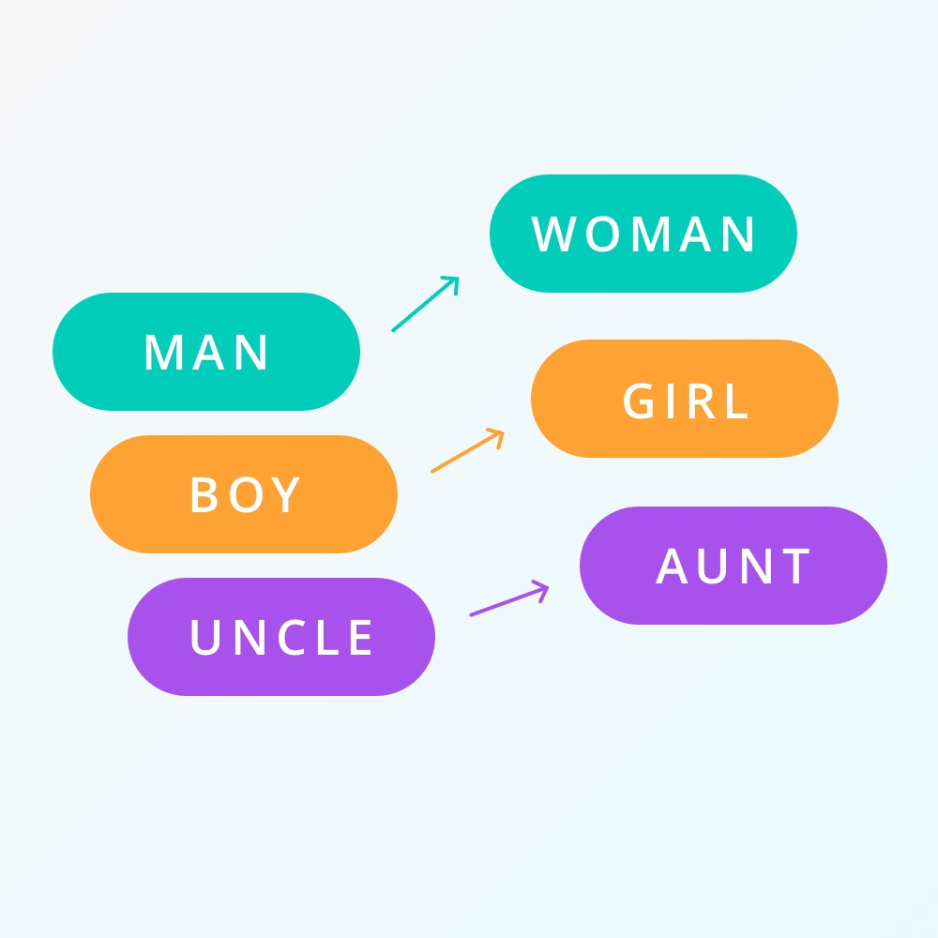](https://classroom.udacity.com/courses/nd101-preview/lessons/426d0195-bdf8-4099-af00-fa1e236c244e/concepts/36217037-98a7-441e-874a-251a0d13b2b4)](https://classroom.udacity.com/courses/nd101-preview/lessons/426d0195-bdf8-4099-af00-fa1e236c244e/concepts/36217037-98a7-441e-874a-251a0d13b2b4)**

You'll combine embeddings and an RNN to predict the sentiment of movie reviews, an example of common tasks in natural language processing.

In the **third project**, you'll use what you've learned here to generate new TV scripts from episodes of The Simpson's.

**[[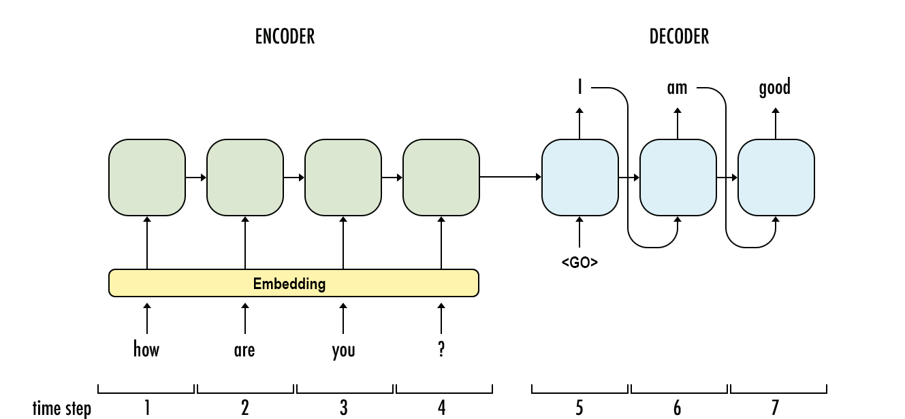](https://classroom.udacity.com/courses/nd101-preview/lessons/426d0195-bdf8-4099-af00-fa1e236c244e/concepts/36217037-98a7-441e-874a-251a0d13b2b4)](https://classroom.udacity.com/courses/nd101-preview/lessons/426d0195-bdf8-4099-af00-fa1e236c244e/concepts/36217037-98a7-441e-874a-251a0d13b2b4)**

## Generative Adversarial Networks

Generative adversarial networks (GANs) are one of the newest and most exciting deep learning architectures, showing incredible capacity for understanding real-world data. The networks can be used for generating images such as the **[CycleGAN](https://github.com/junyanz/CycleGAN" \t "_blank)** project.

**[[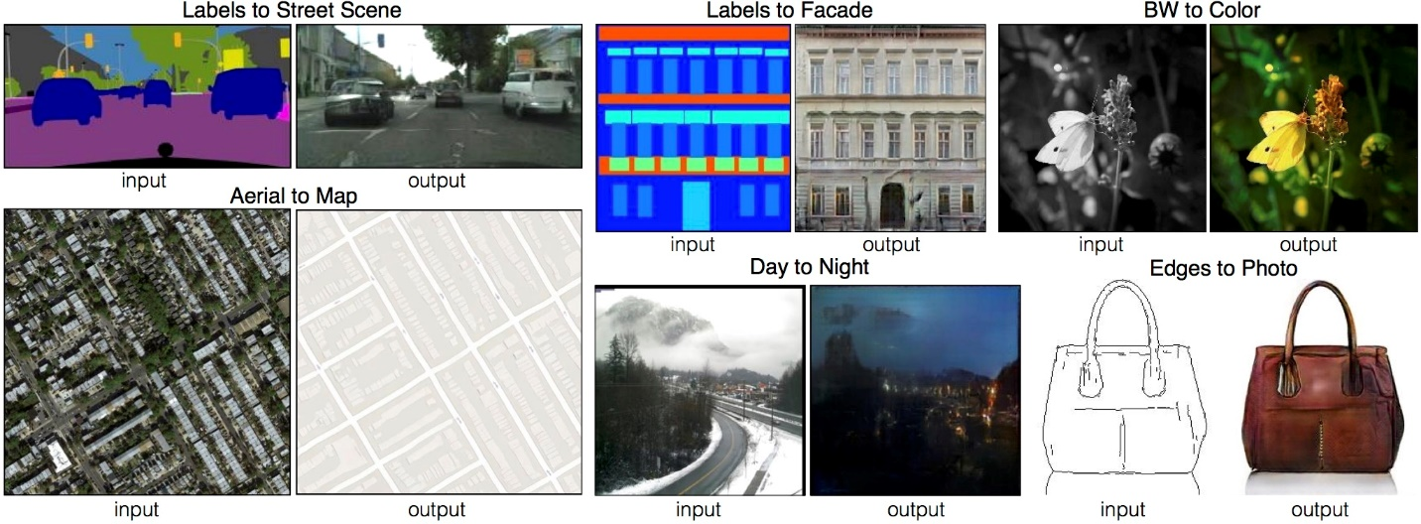](https://classroom.udacity.com/courses/nd101-preview/lessons/426d0195-bdf8-4099-af00-fa1e236c244e/concepts/36217037-98a7-441e-874a-251a0d13b2b4)](https://classroom.udacity.com/courses/nd101-preview/lessons/426d0195-bdf8-4099-af00-fa1e236c244e/concepts/36217037-98a7-441e-874a-251a0d13b2b4)**

The inventor of GANs, Ian Goodfellow, will show you how GANs work and how to implement them. You'll also learn about semi-supervised learning, a technique for training classifiers with data mostly missing labels.

In the **fourth project,** you'll use a deep convolutional GAN to generate completely new images of human faces.

**[[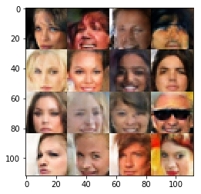](https://classroom.udacity.com/courses/nd101-preview/lessons/426d0195-bdf8-4099-af00-fa1e236c244e/concepts/36217037-98a7-441e-874a-251a0d13b2b4)](https://classroom.udacity.com/courses/nd101-preview/lessons/426d0195-bdf8-4099-af00-fa1e236c244e/concepts/36217037-98a7-441e-874a-251a0d13b2b4)**

## Deep Reinforcement Learning

Deep reinforcement learning has been in the center of some of the most recent advances in artificial intelligence. For example, it was widely used in the construction of AlphaGo by DeepMind.

In this section you'll use deep neural networks to design agents that can learn to take actions in a simulated environment. You'll then apply it to complex control tasks like video games and robotics.

**[[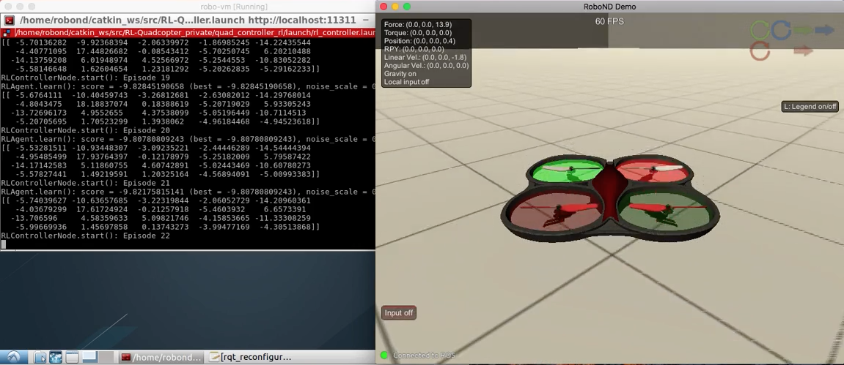](https://classroom.udacity.com/courses/nd101-preview/lessons/426d0195-bdf8-4099-af00-fa1e236c244e/concepts/36217037-98a7-441e-874a-251a0d13b2b4)](https://classroom.udacity.com/courses/nd101-preview/lessons/426d0195-bdf8-4099-af00-fa1e236c244e/concepts/36217037-98a7-441e-874a-251a0d13b2b4)**

In the **fifth project**, you will design a Deep Reinforcement Learning agent to control several quadcopters flying tasks, including take-off, hover, and landing.

1. Projects You Will Build

Most important part of the journey are the projects! 1st neural network = bike rentals, 2nd = dog in picture, 3rd recurrent neural network = generative TV scripts, 4th generative adversarial network to generate novel faces, 5th automate flying drones with deep reinforcement learning.

1. Community Support

Huge key to success is the forums and Slack group. Also, there is an issue site called ‘waffle board’.

1. Prerequisites

We've designed this program such that you only require the following prerequisite knowledge:

* Required
  + [**Intermediate Python experience**](https://www.udacity.com/course/programming-foundations-with-python--ud036).
* Optional
  + [**Multivariable Calculus**](https://www.khanacademy.org/math/multivariable-calculus) and [**Linear Algebra**](https://www.khanacademy.org/math/linear-algebra) if possible.

That being said, we've included a lot of the detailed mathematics for those of you who do want to go in depth and understand the theory behind these concepts. Such content is optional and shouldn't prevent you from doing the projects. However, it is encouraged for a theoretical understanding.

1. Getting set up

Before moving onto the next section, know there will be heavy use of NumPy, matplotlib, and pandas. Recommends intro to Data Analysis Course. Anaconda is a popular package and environment manager built specifically for Data Science. A lot of work will be done in jupyter notebooks. Notebooks are documents that live in your browser, and combine text, code, and images all in one place.